Home Learning
Each week I will be sending home a Friday 5! This will tell you what we have been learning throughout the week and how you can develop this at home too. Photos can be sent in via email at drivenursery@gatedu.org or added to tapestry.

Reading
Reading is so important for the development of your child and is key to learning. We encourage you to read as much as possible with your child. This could be through reading stories with them or to them as part of your bedtime routine.

‘Children are made readers on the laps of their parents’

Book Bags
Book bags are to be brought to school each week so a new reading for pleasure book can be sent home. If you do not have a book bag, please see the School Office.

Snack Fund
We have a weekly donation of £1 for our snack fund. This can be handed to Mrs Calvert or Ms Grant.

50p Friday
Every Friday Nursery children are able to choose a treat from the box. If you would like your child to participate please give 50p to Mrs Calvert on a Friday before your child’s session.

Spring Term 2024


Nursery

Mrs Calvert and Ms Grant

Information for Children,
Parents and Carers

In Nursery, we take influence for our curriculum from children’s interests. This is to ensure we provide the children with an engaging curriculum which promotes their love of learning. We follow children’s interests carefully and adapt our provision accordingly. We also have planned focuses this term such as Winter, Lunar New Year and Easter.

Learning through play is a fundamental part of Nursery. Children will have time in their day called ‘Plan Do Review’ that gives your child the opportunity to learn for themselves, by exploring and investigating, watching and listening and creating and communicating.

Warning: Play can be messy, and we love OUTDOORS! There is no such thing as bad weather and each season brings with it new learning opportunities. With this in mind, please ensure your child has an outdoor coat and wellies in school. Throughout Nursery, we are supporting your children to developing their
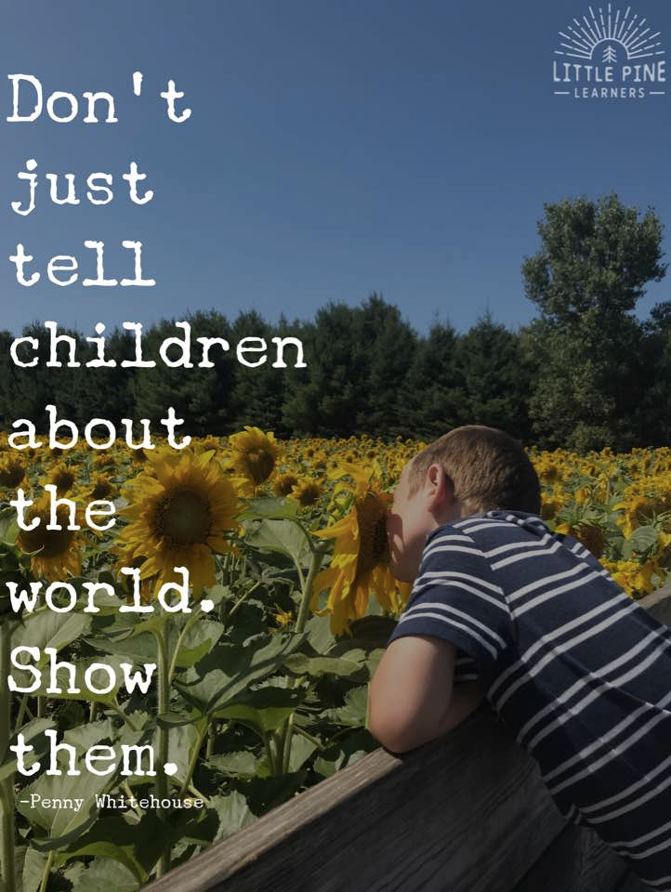
independence, confidence and resilience and outdoor learning promotes this.

Please find a summary of each of the
different areas that will be covered throughout the year.
Communication and Language

Speaking: Speaking is an essential part of a child’s early development. Our Nursery routine is created in a way that embeds speaking and listening at it’s core. Children are supported to develop the necessary skills to enable them to thrive.

Listening: During Spring Term, children will be encouraged to develop their listening skills during through song, small and large group time and activities.

Language: Children are encouraged to develop their language
and communication skills. Children are exposed to a language rich environment which children can explore through their interactions with adults and other children.

Physical Development

Fine Motor Skills: This area of the curriculum looks at developing your child’s fine motor skill in preparation for writing. During out time in Nursery we explore pre-requisite skills to encourage and enable children to develop skills to become independent writers.

Gross Motor Skills: This area of the curriculum focuses on developing your child’s gross motor skills. This allows us to negotiate spaces effectively, move energetically such as running, jumping and hopping and it helps us to develop our strength and co-ordination in order to complete every day tasks.

Personal, Social and Emotional Development

Building Relationships: This term we will be continuing to encouraging your child to continue to grow in confidence and explore various social situations.

Managing Self: Children will be encouraged to develop their confidence through their play and with the support of the adults in the classroom. Small group activities this term will encourage this development. We will be looking at the various things we can do to help build our confidence.

Self Regulation: We will continue to support children with regulation. In Nursery we can be overcome with such big emotions. Children are supported through these through positive interactions and provided with techniques to support them to be able to self regulate.

Literacy

Comprehension: At this age, children develop early reading skills that form an important foundation for starting school and fostering a love of reading. Your child will be supported and encouraged to listen to stories and join in, to retell stories in their own words and to sing songs and simple rhymes.

Writing: Early writing will often combine pictures, words and symbols all in one text. Children may talk to themselves or others as they draw and write and will use symbolic representations alongside or in place of alphabetic code.

Word Reading: Through stories, children will talk about the meaning of words. This may start with an adult providing and talking about the children’s interest and supporting them to build on their knowledge. Listening to stories introduces children to a wide rename of vocabulary they may not hear in their usual play.

Mathematics

Numbers: Children will be introduced to numerical concepts. We support children with this learning through number rhymes and drawing attention to amounts such as ‘more’ ‘less’

Numerical Patterns: This is all about supporting the foundations for recall of the counting sequence and understanding number operations. We will be using a technique called ‘subitising’ to support children with this understanding. It is an important foundation for later mathematical thinking and reasoning.

Understanding the World
Understanding the world is all about how children get to know about other people, the place where they live and about all aspects of the environment. We support this by encouraging children to explore the world around them and making their own observations through hands on experiences and being able to discover things for themselves.

Expressive Arts and Design

Creating with Materials: We encourage children to choose and use materials and resources in an open-ended way. This helps them to make choices and have confidence in their own ideas.

Being Imaginative and Expressive: This area focuses on how children use what they have learned about media and materials in purposeful and original ways. They may represent their own ideas, thoughts and feelings through art and design, music, dance, role play and stories.

Phonics
In Nursery, our daily routine is embedded with Phase 1 Phonics. Before children learn to read and write they need to develop their phonological and phonemic awareness; being able to listen and identify sounds and how they go together in words. Phase 1 phonics facilitates this and provides a gateway to early reading and writing.

There a seven aspects that we focus on throughout the year:
- Environmental sounds
- Instrumental Sounds
- Body Percussion
- Rhythm and Rhyme
- Alliteration
- Voice Sounds and,
- Oral blending and Segmenting.



