Reading and Contact Books
Reading is so important for the development of your child and is key to learning. With this in mind, we encourage you to read as much with your child as possible. This could be through reading stories with them, or to them as part of their bedtime routine.

‘Reading is food for the mind and soul’

Please ensure that reading and contact books are returned to school every Friday so they can be checked and changed. Please comment in the reading record to show that your child has read at home.

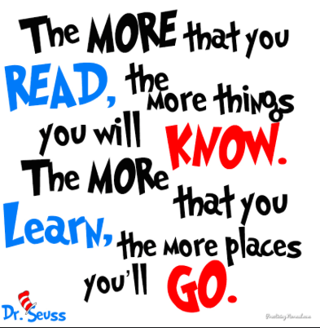

PE Days
PE days are Wednesday and Friday.
Please ensure that your child is wearing the school PE kit which includes: Drive PE top, shorts/tracksuit bottoms and appropriate trainers or plimsolls.

Spring Term 2025
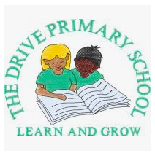

Year 2
Mrs McCartney
Mrs Gallagher

Information for Children,
Parents and Carers.

Our topic this term is China and Explorers.

During this term we will be learning about:

English
Our English work will be based on the book Lin Yi’s Lantern by Brenda Williams. We will write a diary from the point of view of the main character. We will also learn about sequencing and use this to help us write a recount of a real experience.
Maths
In maths, we will learn about multiplication and division. We will also start to learn our times table facts.
Science
Our science topic this term is plants.
We will be investigating and labelling the stages of a plant from a seed or bulb into a mature plant. We will know that plants need water, light and a suitable temperature to grow and stay healthy.
History
The children will learn about explorers this term. We will think about what an explorer is and learn about significant explorers from the past. These will include Neil Armstrong and Christopher Columbus.
Art
Our art lessons will be linked to our geography topic of China. The children will be drawing Chinese artefacts, investigating tone, pattern and shape. They will also be doing some 3D work including making a clay Chinese dragon to develop their skills in sculpture.

Design and Technology
In design and technology, pupils will research different types of puppets then design, make and evaluate their own puppets linked to Chinese New Year.
Geography
In geography, we will study the country China by looking at the geographical features. We will compare agriculture in the UK and China, find out about famous landmarks and use an atlas to improve our map reading skills. We will also learn about what a school day in China is like and compare it to a school day at The Drive.
Religious Education
Pupils will explore how some people have a special connection to God through looking for clues in religious stories. They will also investigate stories that show the characteristics of a prophet and consider what a prophet might mean to some people.
Music
In music, the children will be learning to find the pulse, clap along to a steady beat and play tuned percussion in time to various pieces.
Physical Education
Our PE topic for this term is dance. The children will learn some basic moves and think of ways to link them in a short routine to music.
PSHE
The children will learn about the benefits of exercise and relaxation. They will learn how to manage different emotions, set goals and develop their understanding of dental hygiene. They will also develop their understanding of safety: roads, medicines, an introduction to online safety and the concept of privacy.

