Reading and Contact Books
Reading is so important for the development of your child and is key to learning. With this in mind, we encourage you to read as much with your child as possible. This could be through reading stories with them, or too them as part of your bedtime routine.

‘Reading is food for the mind and soul’

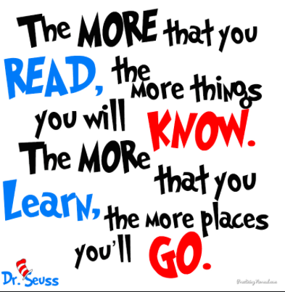
Please ensure that reading and contact books are returned to school every Monday so they can be checked and changed. Please comment in the reading record to show that your child has read at home.

PE Days
PE days are Wednesday and Friday.

Please ensure that your child is wearing the school PE kit which includes: Drive PE top (in your child’s team colour), blue or black shorts/tracksuit bottoms (not branded) and appropriate trainers or plimsolls.

Trips

Beach – provisionally Wednesday 2nd July

Summer Term 2025
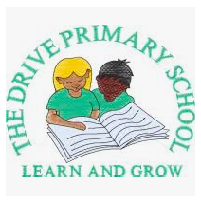

Year 2
Mrs McCartney
Mrs Gallagher

Information for Children,
Parents and Carers

Our topic this term is holidays in the past and weather
During this half term we will be learning about the following:

English
In English we will be reading “Dragon Post” by Emma Yarlett. Our focus will be writing letters and postcards and answering questions about the text.

Maths
In maths, we will be focusing on division, shape, addition and subtraction, fractions and time.

Science
In science our topic will be ‘animals including humans’. In this topic we compare how animals change as they grow. We match animals to their babies and look at their life cycles. We will study the life cycle of a butterfly and write about the changes we observed. We will also make posters on how humans should keep fit and healthy.

History
Our history topic will be looking at holidays in the past and comparing them to the types of holidays taken now, as well as comparing similarities and differences.

Geography
Our geography topic is weather. We will monitor the weather in our local area every day and compare it to another country with very different weather. We will also find out about different kinds of wild weather and their effects on the earth.

Religious Education
In RE, we will be learning about places of worship and how people talk to God through prayer.

Music
In music we will continue to build up our skills of learning songs, moving and clapping to different rhythms/beats and using tuned and untuned percussion instruments.

Physical Education
In PE, we will be doing striking, fielding and athletics.

PSHE
In PSHE, the children will be learning about citizenship, rules outside of school, caring for the local environment and economic wellbeing.

Art and D&T
Our art will be linked to our theme of weather and we will be developing collage and printing skills. In D&T, we will be making a vehicle for an explorer to travel in. We will develop various skills including joining and cutting.

