Year 1 Autumn – Drawing and sculpture
Topic link ; Local area
Artist ; Antony Gormley

Knowledge of artist / generating ideas  Look at work of Antony Gormley  Use oracy activities to evaulate  Collect work in sketchbooks  *See progression document ‘Knowledge of artist’ | Drawing activities  1. Experiment making different lines in sketchbooks.  2. Make an observational drawing of the Angel of the North. Consider shape, line e.t.c.  Final piece ; Drawing of the angel of the North  Skills  - Experimenting to create different lines and marks made with a range of media.  - Observe shape and line when making an observational drawing | Sculpture activities  1.Experiment with playdough, plasticine or clay. Try different ways of manipulating e.g. rolling, kneading, pinching, flattening.  2. Show to use sculpture tools safely.  3. Use skills practised to make an angel of the North sculpture using playdough, plasticine or clay.  Final piece : Sculpture of angel of the North  Skills  - Manipulate malleable materials in a variety of ways including rolling and kneading.  - Explore sculpture with a range of malleable media.  - Understand the safety of materials and tools. | Evaluate work  *See progression document ‘Evaluating and analysing.’
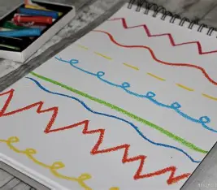

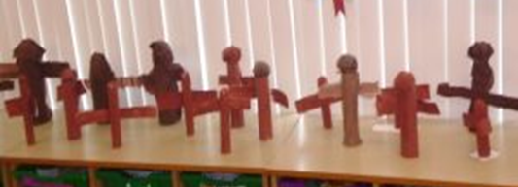

Evaluate and analyse / use oracy in art suggestions from talksparks
Compare features of their own and others’ artwork.

Autumn cross curricular lesson : Paint a family tree
Paint in the style of Seurat (dabbing technique / Pointillism)
Paint a tree to be made into a family tree.

Skills
- Experimenting to produce a range of effects.
- Using a variety of tools and techniques including different brushes and investigating the kinds of marks which can be made.

Year 1 Spring – Drawing
Topic link ; Toys
Artist ; Henry Maryarm Arslan, Nicola McBride, Pablo Picasso.

Knowledge of artist / generating ideas  Compare artists  Henry Maryarm Arslan ‘English breakfast’ ,  Nicola McBride ‘Spread the happy’ and Pablo Picasso ‘Still life with lamp.’  Use oracy activities – which would they give the gold / silver / bronze medal and why.  Collect work in sketch books and discuss.  *See progression document ‘Knowledge of artist’ | Drawing activities  1. Experiment with a range of media in sketchbooks e.g. pencils, rubbers, crayons, pastels, felt tips, charcoal, ballpoints, chalk. Discuss how they create different effects  2. Make observational drawings of a chosen toy. Consider shape, line e.t.c.  3. Try doing multiple drawings of the toys using different media e.g. one week draw a toy using pencil, the next week draw a toy using felt tip, then draw a different toy using chalk e.t.c.  Final piece ; Observational drawings of toys in different media  Skill  - Drawing with a range of media e.g. pencils, rubbers, crayons, pastels, felt tips, charcoal, ballpoints, chalk.  - Observing shape, line and pattern when drawing. | Evaluate work  *See progression document ‘Evaluating and analysing.’
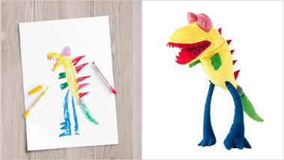
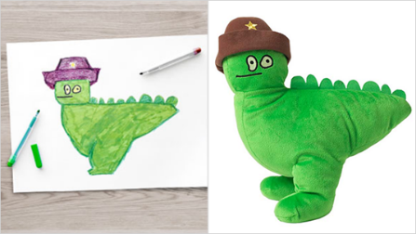
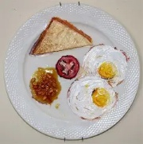
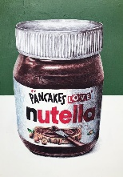
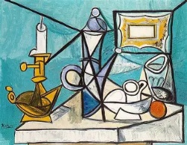

Evaluate and analyse / use oracy in art suggestions from talksparks
Compare features of their own and others’ artwork.

Spring cross curricular lesson : Print with toys
Print using toys e.g. lego, toy cars

Skills
- Using objects to make prints.
- Creating simple printing blocks using press printing techniques.
- Creating different simple designs by repeating patterns.
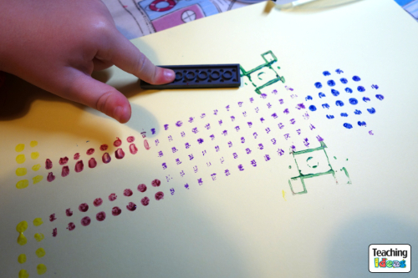
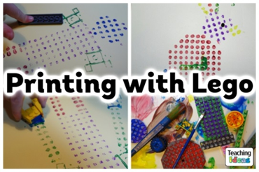
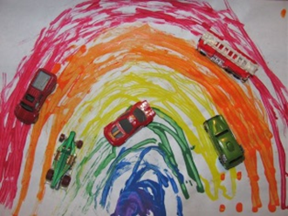

Year 1 Summer – Painting
Topic link ; China / Shanghai
Artist ; Multiple images of Chinese art / craft

Knowledge of artist / generating ideas  Collect images of Chinese art in sketchbooks. Compare. Comment on bright colours used.  *See progression document ‘Knowledge of artist’ | Painting activities  1. Identify the three primary colours (red, blue, yellow). Explain these are the colours we cannot make by mixing others. Explore how to mix primary colours. Experiment with colour mixing in sketchbooks.  2. Experiment making marks with a range of different brushes and using different techniques.  3.Show pictures of Chinese art, traditional clothing, and festivals. Highlight red as an important colour in Chinese culture (symbol of luck and happiness). Explain that Chinese art often uses bright colours and patterns.  4. Model how to draw a Chinese dragon, considering shape and line. Children use their mixed colours to paint a colourful Chinese dragon using the brush techniques they have practised.  5. Pupils could try with poster paint then with watercolour paint.  Final piece ; Chinese dragon painting  Skills  ● Using a variety of paint media and experimenting to produce a range of effects.  ● Using a variety of tools and techniques including different brushes and investigating the kinds of marks which can be made.  ● Identifying primary colours and undertaking simple colour-mixing.  ● Matching colours to artefacts and objects. | Evaluate work  *See progression document ‘Evaluating and analysing.’
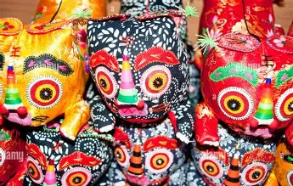
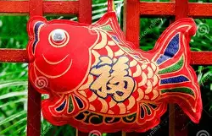
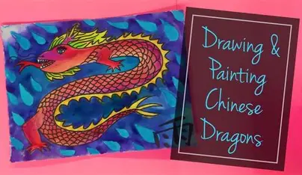

Evaluate and analyse / use oracy in art suggestions from talksparks
Compare features of their own and others’ artwork.

Summer cross curricular lesson : Collage an explorer
Make a group collage of a chosen explorer

Skills

• Add collage to a given template / image.
• Match and sort fabrics and threads for colour, texture, size, length and shape.
• Cut and shape materials using scissors.
• Apply shapes and decoration with glue.

