Year 2 Autumn – Painting and mixed media
Topic link ; Great fire of London
Artist ; Ed Swarez

Knowledge of artist / generating ideas  Look at work of Ed Swarez ‘Inferno.’  Use oracy activities to evaulate  Collect work in sketchbooks and anootate.  *See progression document ‘Knowledge of artists.’ | Painting activities  1. Experiment with colour mixing in sketchbooks. Revise primary colours and practise mixing to make secondary colours.  2.Look at work of Ed Swarez and discuss how he has made marks to represent fire. Practise doing this in sketchbooks.  3. Paint a fire background using red, yellow and orange. Mix red and yellow to make orange.  4. Use collage to add buildings. Add some flame collage using tearing and overlapping skills.  Final piece ; Great fire of London artwork using paint and mixed media.  Skills  - Using paint to produce a range of effects.  - Identifying primary colours and undertaking simple colour-mixing to make secondary colours.  - Using a variety of tools and techniques including different brushes and investigating the kinds of marks which can be made.  - Naming different types of paint and their properties.  Collage  • Creating an image using collage using a range of media.  • Cut and shape materials using scissors.  • Tearing and overlapping papers. | Evaluate work  *See progression document ‘Evaluating and analysing.’
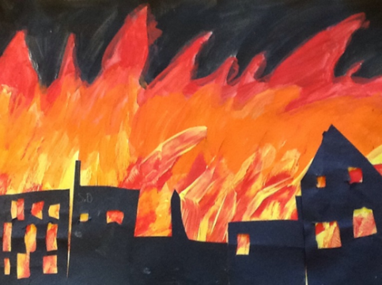
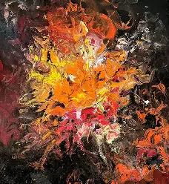

Evaluate and analyse / use oracy in art suggestions from talksparks
Compare features of their own and others’ artwork.

Autumn cross curricular lesson : Collage
Collage of river with buildings. Contrast the manmade aspect of buildings to the river and choose appropriate materials and techniques to reflect this.

Skills
• Creating an image using collage using a range of media.
• Sorting and grouping materials for different purposes e.g. colour, image, texture.
• Cut and shape materials using scissors.
• Folding, crumpling, tearing papers.
• Applying decoration e.g. sequins on the river

Year 2 Spring – Sculpture and collage
Topic link ; Why is our world wonderful?
Artist ; Barbara Hepworth, Andy Goldsworthy

Knowledge of artist / generating ideas  Learn about Barbara Hepworth and Andy Goldsworthy. Compare materials they used and abstract nature of their sculptures.  Collect work in sketch books and discuss.  *See progression document ‘Knowledge of artists.’ | Sculpture activities  1.Experiment with clay using rolling, scratching, squeezing, pinching e.t.c.  2.Create a natural object using the skills practised from clay e.g. a tree, flower or animal.  3. Collect some natural objects e.g. twigs, pine cones and leaves. Make a land art sculpture like Andy Goldsworthy.  4. Make a showcase collage using photos of nature sculptures made decorated with pictures of natural materials you have used. Add some real natural materials.  Skill  - Shaping malleable materials in a variety of ways including squeezing, rolling, flattening and pinching.  - Impressing different textures and patterns using a variety of objects.  - Modelling, constructing and joining recycled, natural and man-made materials.  - Investigating different joining techniques.  - Understand the safety of materials and tools.  Collage skills  • Creating an image using collage using a range of media.  • Cut and shape materials using scissors.  • Folding, crumpling, tearing papers.  • Applying decoration using natural and manmade materials. | Evaluate work  *See progression document ‘Evaluating and analysing.’
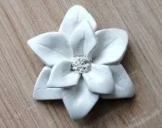
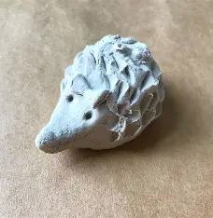
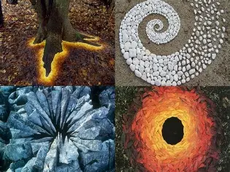
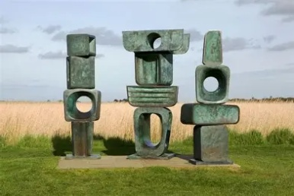

Evaluate and analyse / use oracy in art suggestions from talksparks
Compare features of their own and others’ artwork.

Spring cross curricular lesson : Printing
Ask: “What things can fly?” (birds, planes, butterflies, rockets). Show pictures or short video clips of flying objects. Introduce the idea: “We’re going to make a sky full of flying things using printing. Show how to dip a sponge or potato stamp into paint and press it onto paper. Children choose shapes (bird, plane, butterfly). Print multiple times to create a busy sky scene.
Encourage mixing colours and overlapping prints for creativity. Share artwork and talk about what they printed. Reinforce vocabulary: flying, sky, wings, soar

Printing skills

- Using a growing range of objects to make prints.
- Creating simple printing blocks using press printing techniques.
- Creating designs by repeating patterns.
- Exploring colour mixing through overlapping colour print.

Year 2 Summer – Drawing
Topic link ; Monarchy (Kings, Queens and Castles)
Artist ; Paul Klee

Knowledge of artist / generating ideas  Learn about Paul Klee.  Discuss his use of shape and colour in ‘Castle and Sun.’ Collect ideas in sketchbooks.  *See progression document ‘Knowledge of artists.’ | Drawing activities  1.Experiment with using a range of media to make varied lines / marks in sketchbooks e.g. crayon, pastels, felt tips, charcoal, pen.  2.Decide which medium they would like to use to draw a portrait of a King or Queen. Model how to draw then they produce a portrait.  3.Investigate tone in sketchbooks – drawing light /dark lines, light / dark patterns, light / dark shapes. Draw a crown using tone. Try in pencil and charcoal.  3. Draw a castle from observation. Consider shape.  4. Make their castle abstract like Paul Klee. Use oil pastels to colour.  Skills  • Drawing with a range of media e.g. pencils, rubbers, crayons, pastels, felt tips, charcoal, ballpoints, chalk.  • Experimenting to create different lines and marks made with a range of media.  • Name, match and draw lines / marks from observations.  • Draw shapes in between objects.  • Investigate tone by drawing light / dark lines, light / dark patterns, light / dark shapes. | Evaluate work  *See progression document ‘Evaluating and analysing.’
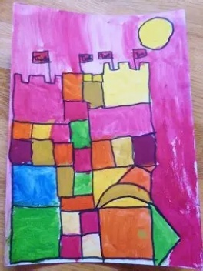
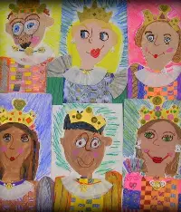
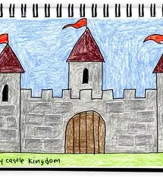
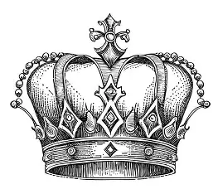
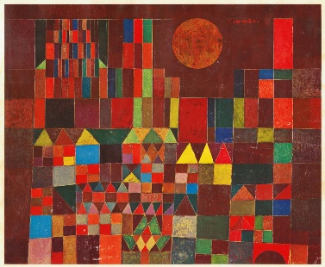

Evaluate and analyse / use oracy in art suggestions from talksparks
Compare features of their own and others’ artwork.

Summer cross curricular lesson : Textile / collage a crown
Collage of a King or Queen’s crown.

Skills
• Creating an image using collage using a range of media.
• Sorting and grouping materials for different purposes e.g. colour, image, texture.
• Cut and shape materials using scissors.
• Folding, crumpling, tearing papers.
• Arranging and gluing materials to different backgrounds including fabric shapes.
• Applying decoration using beads, buttons, sequins, feathers etc.

