Year 3 Autumn – Painting
Topic link ; Stone Age
Artist ; Stone Age art

Knowledge of artist / generating ideas  Learn about Stone age art / cave art  *See progression document ‘Knowledge of artists.’ | Painting activities  1. Experiment in sketch books making tints, tones and shades. Discuss how we can use these elements when showing the effect of light.  2.Create blue Stonehenge paintings using tints, tones and shades to show the effect of light.  3.Discuss how colour can create different atmospheres. Use reds and yellows to make a Stonehenge painting with a different atmosphere.  Skills  • Creating imaginative work from a variety of sources e.g. observational drawing, themes, inspirational works of art.  • Creating different effects using a range of techniques and paints.  • Build upon knowledge of colour theory, in particular tints, tones and shades.  • Using colour to create atmosphere and to show the effect of light. | Evaluate work  *See progression document ‘Evaluating and analysing’
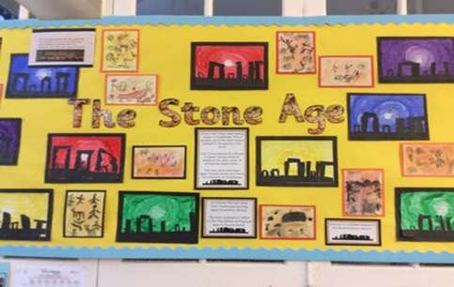
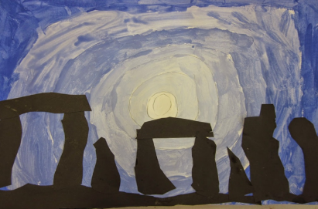

Evaluate and analyse / use oracy in art suggestions from talksparks
Compare features of their own and others’ artwork.

Autumn cross curricular lesson : Printing
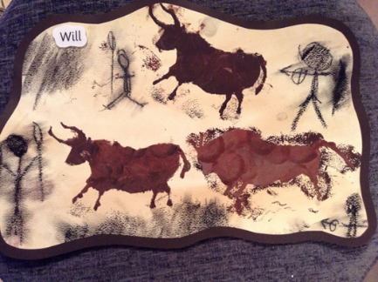
Create a group printing piece based on cave printing / Anglo Saxons.

Skills
- Using initial sketchbook ideas to create motifs that are made into stencils.
- Creating stencils and using them to create a simple print.

Year 3 Spring – Sculpture
Topic link ; Romans
Artist ; Roman art and architecture

Knowledge of artist / generating ideas  Look at features of Roman art and architecture. Collect and annotate / evaluate in sketchbooks.  *See progression document ‘Knowledge of artists.’ | Sculpture activities  1. Learn the clay coil method. Make a coil pot.  2.Revise methods used in sculpture e.g. pinching, squeezing, safe use of tools e.t.c. Make an oil lamp. Use tools to add pattern / texture.  3. Practise joining skills when using cardboard and junk materials. Make a Roman shield and paint it.  Skills  - Planning and designing sculptures from observation or imagination using sketchbook ideas.  - Using recycled, natural and man-made materials to create sculptures including clay and cardboard.  - Developing skills in using clay including modelling, joining, oil lamp, coil pots.  - Creating more intricate patterns and textures when using malleable materials such as clay.  - Joining materials with increasing skill. | Evaluate work  *See progression document ‘Evaluating and analysing’
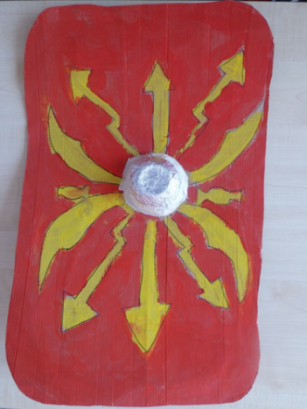
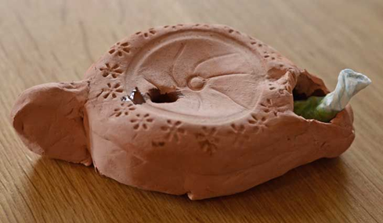
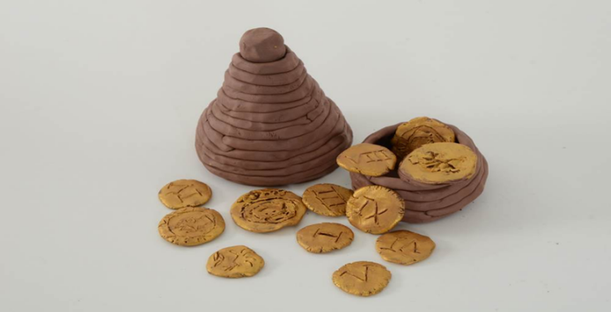

Evaluate and analyse / use oracy in art suggestions from talksparks
Compare features of their own and others’ artwork.

Spring cross curricular lesson : Collage
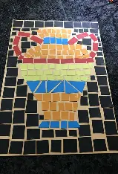
Use squares in chosen material e.g. paper / foam to make a Roman mosaic

Skills
- Exploring how colour, repetition, and arrangement can be used to represent images and decorative designs.
- Developing techniques in pattern, shape, and composition

Year 3 Summer – Drawing
Topic link ; Ancient Egypt
Artist ; Ancient Egyptian art

Knowledge of artist / generating ideas  Look at features of Ancient Egyptian art. Collect ideas in sketchbooks.  *See progression document ‘Knowledge of artists.’ | Drawing activities  1.Experiment in sketch books with different grades of pencil to achieve variations in tone. Draw an Egyptian using variations in tone.  2.Make a close up drawing of an Egyptian mask using black drawing pens.  3. Use felt tip pens to create an Egyptian mummy. Consider shape, pattern, colour and line.  Skills  Drawing  • Use sketchbooks to collect and record visual information from different sources.  • Draw for a sustained period of time at an appropriate level.  • Make marks and lines with a wide range of drawing implements e.g. charcoal, pencil, crayon, chalk, pastels, pens e.t.c.  • Experiment with different grades of pencil and other implements to create lines and marks.  • Begin to show an awareness of objects having a third dimension.  • Experiment with different grades of pencil and other implements to achieve variations in tone.  • Apply tone in a drawing in a simple way. | Evaluate work  *See progression document ‘Evaluating and analysing’
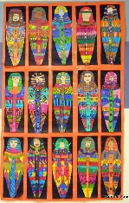

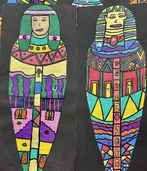
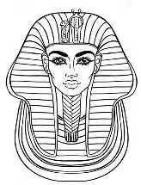
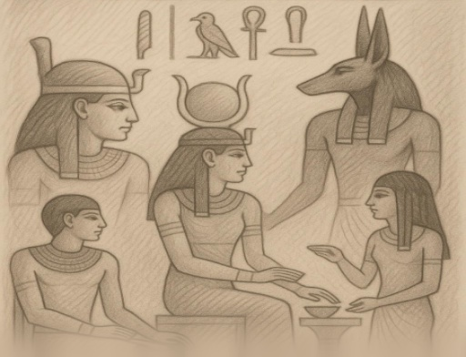
Evaluate and analyse / use oracy in art suggestions from talksparks
Compare features of their own and others’ artwork.

Summer cross curricular lesson : Textile techniques
Tea dye paper and add hieroglyphs.

Skills

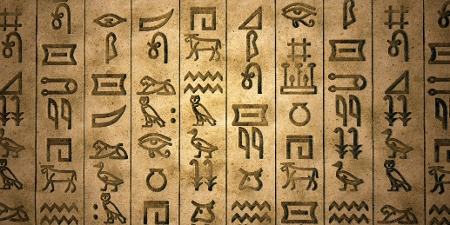
• Use tea dying to create a particular effect.

