Year 4 Autumn – Sculpture
Topic link ; Anglo Saxons
Artist ; Anglo Saxon art

Knowledge of artist / generating ideas  Look at Anglo Saxon art e.g. crosses / jewellery designs. Collect examples in sketchbooks – analyse and evaluate.  *See progression document ‘Knowledge of artists’ | Sculpture activities  1.Look at imagery of Anglo Saxon symbols and create sketchbook pages of designs. Discuss materials that would have been used to create these crosses.  2.Use cardboard to create Anglo Saxon crosses. Add small cardboard pieces to the crosses using PVA glue. Add cardboard patterns in layers to create texture and depth.  3. Discuss paint type and colour to create a rustic / traditional appearance. Choose a paint scheme either in coppers / browns or greys / silvers. Add shading with dark paint using a dry brush and sponges.  4.Use POSCA pens to add detail to the crosses.  5. If time allows, using a similar method to creating the crosses, the children can use cardboard to create their own, hand crafted, pendant. Design in sketchbooks and embellish using a range of materials e.g. beads / buttons. Use a variety of joining methods e.g. punching holes, gluing, wrapping and sewing.  Skills  - Planning and designing sculptures from observation or imagination using sketchbook ideas.  - Using recycled, natural and man-made materials to create sculptures including clay and cardboard.  - Extending 3D skills including modelling, joining.  - Creating detail using a range of materials. | Evaluate work  *See progression document ‘Evaluating and analysing’
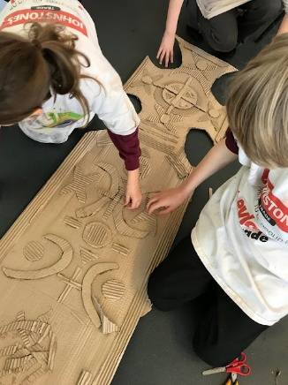
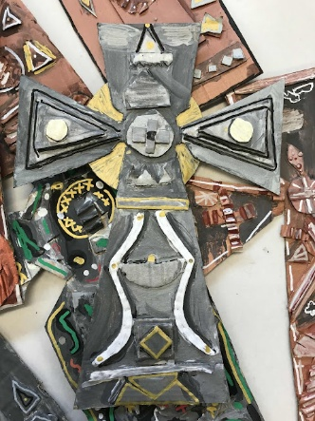
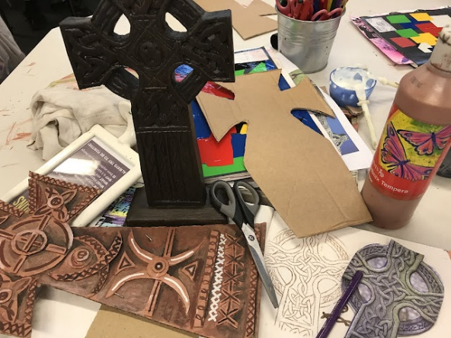
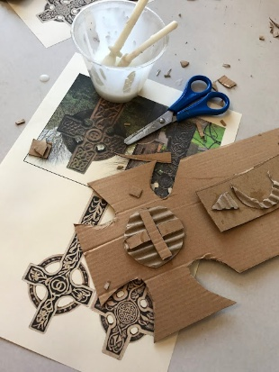

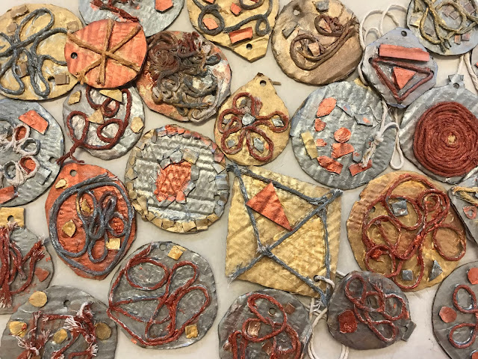
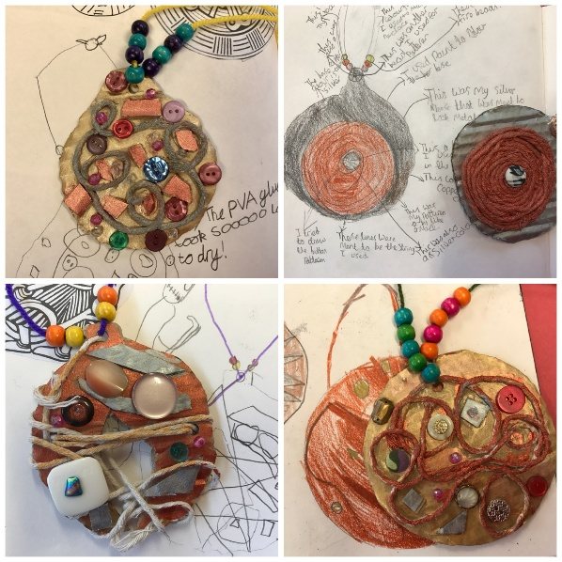
Evaluate and analyse / use oracy in art suggestions from talksparks
Compare features of their own and others’ artwork.

Autumn cross curricular lesson : Printing
Make illuminated letters using printing tiles.
Skills
- Using initial sketchbook ideas to create motifs that are made into printing blocks.
- Creating printing blocks using a relief method.

Year 4 Spring – Drawing
Topic link ; Victorians
Artist ; L.S.Lowry, David Hockney

Knowledge of artist / generating ideas  Compare artists  L.S.Lowry and David Hockney. Compare rural (Hockney) to urban art (Lowry). Collect work in sketchbooks – evaluate and analyse.  *See progression document ‘Knowledge of artists’ | Drawing activities  - Experiment in the various marks that can made using different drawing implements e.g. colouring pencils , wax crayons, pastels (chalk and oil) and pens.  - Explore different ways to add surface detail to drawings through applying different patterns and textures including shading and hatching. Experiment in sketch books.  - Look at the work of Lowry and ask children to plan and create a piece of work using the same style but of a local street nowadays. Draw in the style of Lowry using chosen drawing implement. Use observation, photographs and digital images.  - Look at the work of Hockney and ask the children to plan and create a piece of work using the same style but of a rural area that is familiar to them. Use observation, photographs and digital images.  Skills  ●Using sketchbooks to collect and record visual information and ideas from different sources.  ●Working from a variety of sources including observation, photographs and digital images.  ●Making marks and lines with a wide range of drawing implements including colouring pencils, wax crayons, pastels (chalk & oil) and pens.  ●Exploring ways in which surface detail can be added to drawings through applying different patterns and textures, including shading and hatching. | Evaluate work  *See progression document ‘Evaluating and analysing’
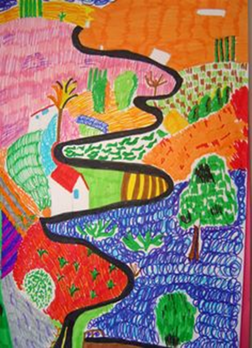
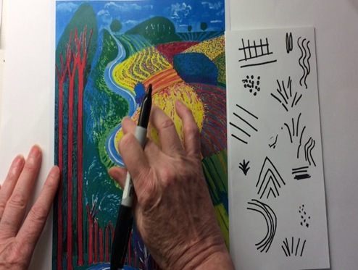
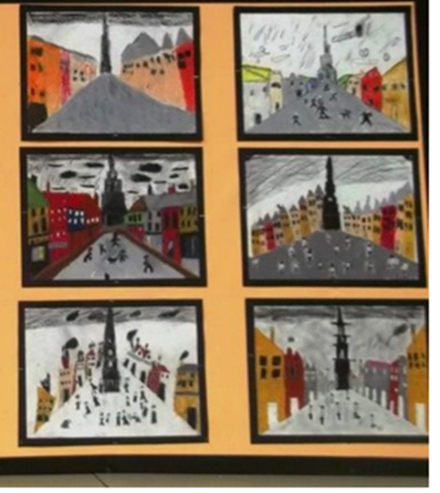
Evaluate and analyse / use oracy in art suggestions from talksparks
Compare features of their own and others’ artwork.

Spring cross curricular lesson : Collage
Create a collage of a Victorian room or building
Skills
• Using collage as a means of expression from sketchbook ideas.
• Using a range of media to create collages.
• Observing and designing of textural art. Develop use of collage techniques to create images and textures such as: tearing, overlapping and layering.
• Create mixed media art,adding collage to a painted, printed or drawn background.
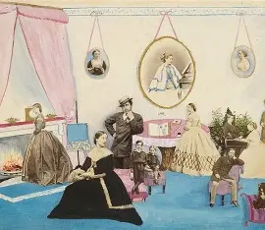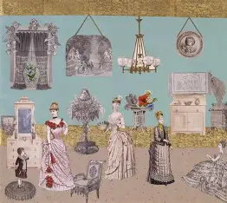

Year 4 Summer – Painting
Topic link ; Mayans / rainforest
Artist ; Henri Rousseau

Knowledge of artist / generating ideas  Learn about Henri Rousseau. Collect some examples of his work. Evaluate and analyse.  *See progression document ‘Knowledge of artists’ | Painting activities  1.Draw a plant from observation, considering shape and line.  2.Practise in sketchbooks making tints, tones and shades that can be used when painting the plant e.g.in greens, browns.  3. Practise scraping technique in sketchbooks to add texture and detail to paint when painting the leaves.  4.Use skills practised to turn their drawing into a plant painting.  Skills  ●Creating imaginative work from a variety of sources e.g. observational drawing, themes, inspirational works of art.  ●Developing a painting from a drawing, including sketchbook ideas.  ●Creating different effects and textures using a range of techniques and paints.  ●Extending knowledge of colour theory to include tints, tones and shades. | Evaluate work  *See progression document ‘Evaluating and analysing’
Evaluate and analyse / use oracy in art suggestions from talksparks
Compare features of their own and others’ artwork.

Summer cross curricular lesson : Textiles
Make a Mayan headband.

Skills

• Cut and shape materials using scissors.
• Apply shapes and decoration with glue.
• Experimenting with a range of media to overlap and layer, creating interesting colours, texture and effects.
• Further developing skills in using tools to manipulate textiles through cutting and joining
• Developing experience in embellishing to enhance the textile.



