Year 5 Autumn – Painting
Topic link ; Mountains
Artist ; O’Keefe , Cezanne, Alma Thomas

Knowledge of artist / generating ideas  Compare mountain work of the 3 artists.  Use oracy activities to evaulate  Collect work in sketchbooks  *See progression document ‘Knowledge of artists’ | Painting activities  - Use sketchbooks to collect and record visual information and ideas from different sources e.g. look at mountain work of different artists (O’Keeffe, Cezanne, Van Gogh). Work from a variety of sources (observation, photographs, digital images). Draw mountains using pencils 5B – 5H, pastels, pens. Use simple perspective in their work.  - Develop mountain paintings from drawings in sketchbooks. Create different effects using a range of techniques and paints. Use colour to create effects of light. Develop awareness of composition, scale and proportion in their paintings. Use simple perspective.  Skills  - Creating imaginative work from a variety of sources such as observational drawings and inspirational works of art.  - Developing a painting from a drawing, including sketchbook ideas.  - Extending their knowledge of colour theory through mixing primary and secondary colours, tints, tones and shades.  - Developing an awareness of composition, scale and proportion in their paintings.  - Creating different effects and textures using a range of techniques and paints.  - Developing a painting from a drawing, including sketchbook ideas. | Evaluate work  *See progression document ‘Evaluating and analysing’
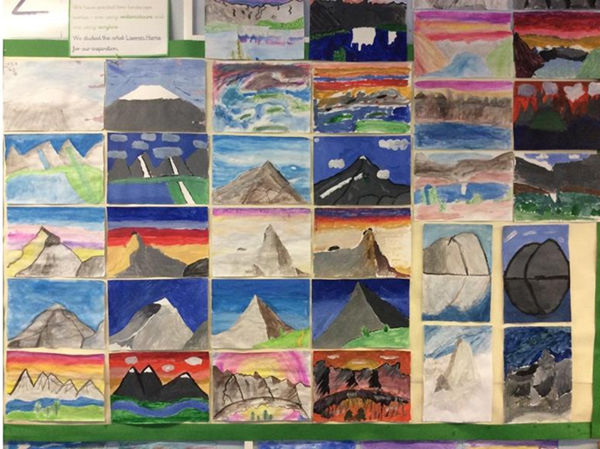
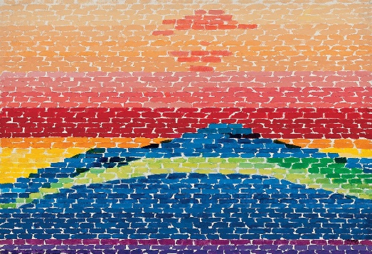
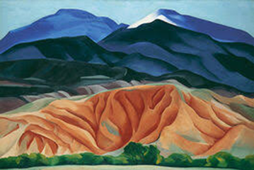

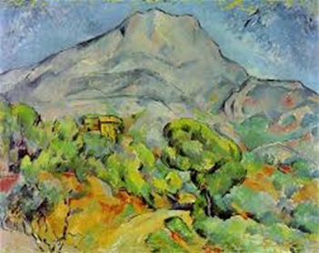
Evaluate and analyse / use oracy in art suggestions from talksparks
Compare features of their own and others’ artwork.

Autumn cross curricular lesson : Printing runes (Vikings)
Create a string printing block and use to print runes.

Skills
- Creating string printing blocks
- Creating prints using a string painting block

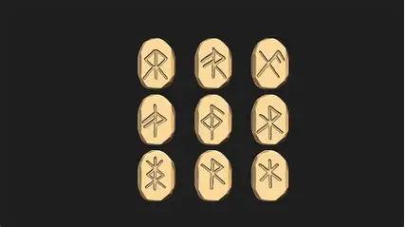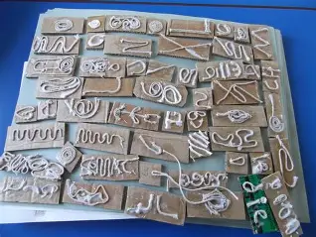

Year 5 Spring – Drawing
Topic link ; World war 2
Artist ; Henry Moore ‘Shelter drawing’ and Laura Knight ‘Land army girl’ / ‘Women in the war effort.’

Knowledge of artist / generating ideas  Compare the different perspectives shown in Henry Moore art ‘Shelter drawing’ and Laura Knight’s artwork showing women in world war 2. Discuss how it affected different people in different ways and the role of women in world war 2 as depicted in Laura Knight’s artwork.  Collect in sketchbooks and evaluate / analyse.  *See progression document ‘Knowledge of artists’ | Drawing activities  - Experiment using different media in sketchbooks e.g. fine line pens, pastel (chalk and oil) Explore ways surface detail can be added to drawings e.g. texture through shading, hatching. Practise shading techniques in sketchbooks e.g. hatching, cross-hatching, scumbling, stippling.  - Use skills practised to draw World War 2 artefacts / soldiers / evacuees in sketchbooks. Work from observation, photographs and digital images. Use a range of media e.g. fine liner pens for artefacts.  - Make silhouette pictures. Consider line / shape when creating silhouettes. Use pastels to create background. Detail can be added to the black silhouette shapes.  Skill  • Using sketchbooks to collect and record visual information and ideas from different sources.  • Working from a variety of sources including observation, photographs and digital images.  • Making marks and lines with a wide range of drawing implements including colouring pencils, fine line pens, pastels (chalk & oil) and pens.  • Exploring ways in which surface detail can be added to drawings through applying different patterns and textures, including shading and hatching. | Evaluate work  *See progression document ‘Evaluating and analysing’
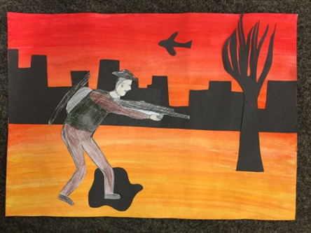
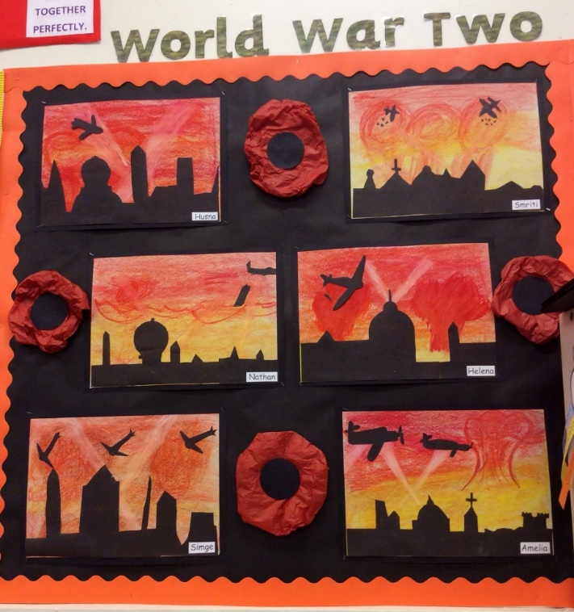
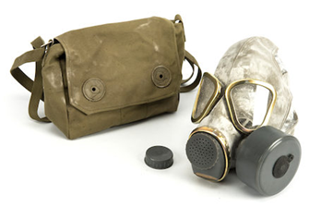
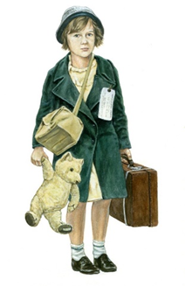

Evaluate and analyse / use oracy in art suggestions from talksparks
Compare features of their own and others’ artwork.

Spring cross curricular lesson : Textiles /collage
Make VE day bunting

Skills
• Developing skills in using tools to manipulate textiles through stitching, cutting, joining.
• Applying a range of decorative finishes to provide detail and to enhance the textile.

Year 5 Summer – Sculpture
Topic link ; Desert / aboriginal sculpture
Artist ; Desert art

Knowledge of artist / generating ideas  Look at examples of desert art traditions e.g. Australian dot painting patterns, North American geometric motifs. Evaluate and analyse.  *See progression document ‘Knowledge of artists’ | Sculpture activities  1. Look at desert photos and artworks (sand dunes, cacti, rock formations) Discuss shapes, patterns, and textures. Sketch ideas for desert-inspired forms.  2.Explore desert art traditions:  * Indigenous Australian dot painting patterns.  * North African geometric motifs. Create design sheets combining natural desert forms with cultural patterns.  3. Introduce clay techniques: pinch, coil, slab. Make a small desert-inspired sculpture (abstract dune form, cactus, or desert animal).  4.Add texture using tools (simulate sand, rock) Apply cultural patterns practised previously. Begin drying process.  5. Paint sculptures using desert colour palette (ochres, browns, reds)  6.Add metallic or patterned details inspired by desert cultures.  Skills  • Shape, form, model and construct from observation or imagination.  • Plan a sculpture through drawing and other preparatory work.  • Develop skills in using clay including slabs, coils, slips e.t.c.  • Produce intricate patterns and textures in a malleable media. | Evaluate work  *See progression document ‘Evaluating and analysing’
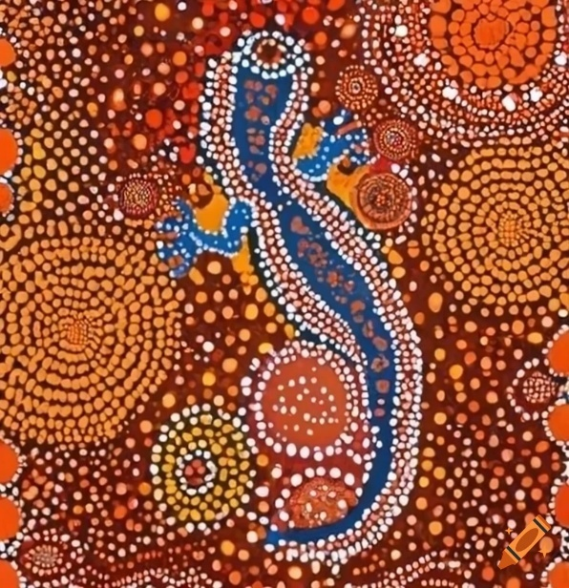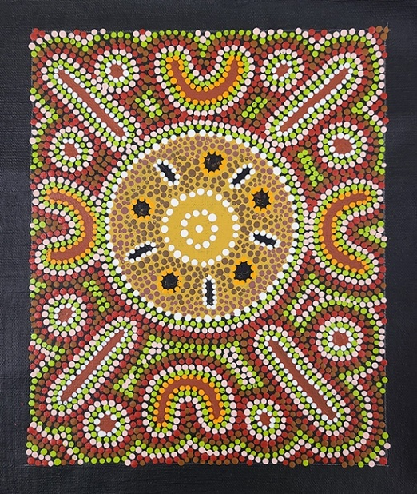

Evaluate and analyse / use oracy in art suggestions from talksparks
Compare features of their own and others’ artwork.

Summer cross curricular lesson : Textiles
Desert weaving – create a desert weaving based on colours / textures from the desert

• Experiencing a range of textile techniques, including weaving, to create different textural effects.

