Year 6 Autumn – Painting
Topic link ; History of keeping healthy
Artist : Frida Kahlo

Knowledge of artist / generating ideas  Look at work of Frida Kahlo – self portraits. Analyse and evaluate.  *See progression document ‘Knowledge of artists.’ | Painting activities  - Look at self portraits of Frida Kahlo and discuss what they tell us about her. Draw own self portraits. Consider how to draw in proportion. Practise techniques for drawing features in sketchbooks e.g. eyes, nose. Work from observation, photographs and digital images.  - Experiment creating different effects and textures using a range of techniques and paints. Add colour to self portraits.  - Look at self portrait work of Kahlo. Add collage around their self portrait drawings to represent ways they stay healthy e.g. exercise / wellbeing / healthy food e.t.c. Consider how collage can represent feelings and ideas.  Skills  - Creating imaginative work from a variety of sources e.g. observational drawing, themes, inspirational works of art.  - Developing a painting from a drawing, including sketchbook ideas.  - Creating different effects and textures using a range of techniques and paints.  - Developing an awareness of composition, scale and proportion in their paintings.  - Add collage / mixed media to represent ideas | Evaluate work  *See progression document ‘Evaluating and analysing’
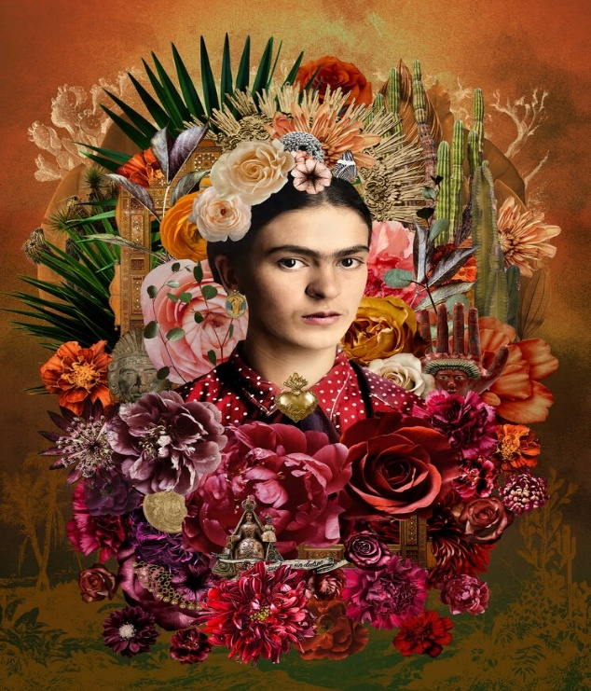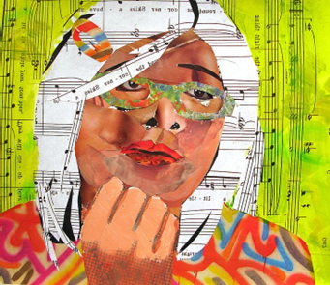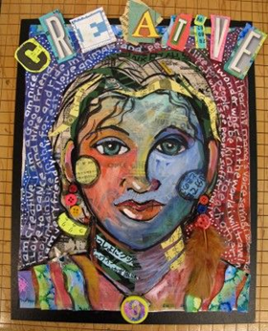

Evaluate and analyse / use oracy in art suggestions from talksparks
Compare features of their own and others’ artwork.

Autumn cross curricular lesson : Collage
Take photographs and create a photomontage of healthy foods / lifestyle / wellbeing

Skills
- Create a photomontage.
- Create artwork for a design brief.
- Use a camera or tablet for photography.

Year 6 Spring – Sculpture
Topic link ; Ancient Greece
Artist ; Ancient Greek art and architecture

Knowledge of artist / generating ideas  Analyse and evaluate Ancient Greek art and architecture. Collect in sketchbooks.  *See progression document ‘Knowledge of artists.’ | Sculpture activities  1 .Plan and design Greek vases in sketchbooks.  2. Use papier mache to make Greek vases (using balloons and cardboard tubes).  3. Create detailed painting on vases.  Skills  • Planning and designing sculptures from observation or imagination using sketch book ideas.  • Using recycled and man-made materials to create sculptures.  • Using recycled, natural and man-made materials to create sculptures using  papier-mâché. | Evaluate work  *See progression document ‘Evaluating and analysing’
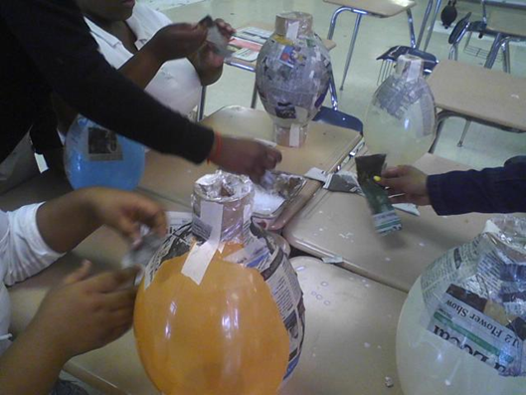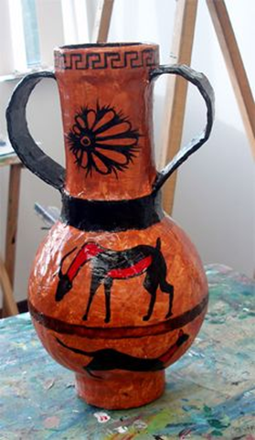
Evaluate and analyse / use oracy in art suggestions from talksparks
Compare features of their own and others’ artwork.

Spring cross curricular lesson : Printing
Design a motif based on the Olympics by simplifying an initial sketchbook idea. Use stencils to print design. Work into prints with a range of media e.g. pens, colour pens and paints. Create a collaborative large scale artwork with motifs.
Skills
- Creating stencils by simplifying an initial sketch book idea.
- Work into prints with a range of media e.g. pens, colour pens, and paints.
- Work collaboratively

Year 6 Summer – Painting, drawing and sculpture
Topic ; School memories
Artist ; Joseph Cornell, Louise Nevelson

Knowledge of artist / generating ideas  Look at examples of sculptures that represent ideas.  Joseph Cornell -  Discuss how he uses assemblage art using boxes filled with found objects, photographs, and personal memorabilia.  Louise Nevelson - monochromatic wooden assemblages, explore texture and form.  *See progression document ‘Knowledge of artists.’ | Activities  1. Look at work of artists and discuss how we could use their ideas to help us with our own work.  2.Explain design brief – to create a memory box of school – using painting, drawing and sculpture. Gather ideas. What could we draw, paint? What are our memories from school? How can we represent these? What 2D and 3D items could we make to go into our memory box and which materials are we going to use?  3. Plan and create our memory box using the skills we have learnt. Think about how the items will be arranged in the box. How are we going to decorate the box?  Skills  - To be able to represent ideas through art.  - To be able to fulfil a design brief.  - To be able to apply a range of skills learnt throughout school. | Evaluate work  *See progression document ‘Evaluating and analysing’
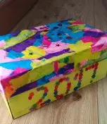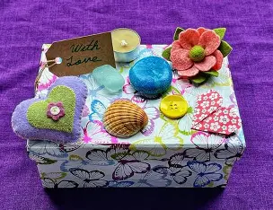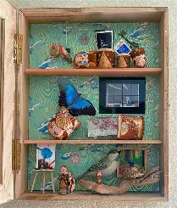

Evaluate and analyse / use oracy in art suggestions from talksparks
Compare features of their own and others’ artwork.

